
SPARK Teams Retreat


June, 2016

Intended purposes for our time together:
- Think and reflect together about the opportunity we have now to support all our students toward success in our school
- Consider how some ideas related to implicit bias and stereotype threat could inform our work as a SPARK team
- Learn in community with other school teams who are also committed to providing high quality, respectful, and equitable experiences for all our students


“We can, whenever and wherever we choose, successfully teach all children whose schooling is of interest to us. We already know more than we need in order to do this. Whether we do it must finally depend on how we feel about the fact that we haven’t so far.”
- Dr. Ron Edmonds, A Blueprint for Action II

TODAY at a Glance

TIME | ACTIVITY
8:30   | GOOD MORNING!  - Getting in the Room Together  - Connecting as a Learning Community  - About Today – Connections to yesterday’s work  - Community Activity – PASEO  - The Art of Conversation – going to a deeper level
INSIDE-OUT Equity Work
- Listening – our best strategy for building relationships and making meaning
- What do WE mean when we talk about equity?
- Building Productive Learning Communities

10:00 | A Systems’ view of our work  - How did we get here? - a historical look at public education  - Understanding how oppression affects teaching and learning and leading  - Systems of advantage and disadvantage
11:30 | LUNCH BREAK
12:30 | How students experience school – some considerations  - Exploring teacher mental models  - Stereotype threat  - Beware of implicit/unconscious bias
12:30 | What’s SPARK got to do with it? Connecting it all together  - Teams make some meaning together about today’s content  - Sharing across school teams
3:15 | Reflections on Today  Commitments as we move forward with our SPARK work
3:30 | Done for Today

What is the Role of Listening in my work?
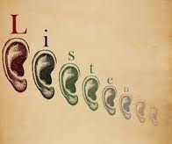

When we begin listening to each other, and when we talk about things that matter to us, the world begins to change. Everyone has the capacity to be able to figure out how to make a difference. Listening and talking to one another heals our divisions and makes us brave again.”
Margaret Wheatley Turning to One Another

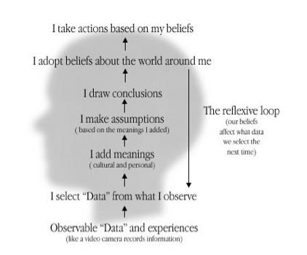
Our Minds at Work

